Major Robert Odell Owens (Librarians We Have Lost, ALA Sesquicentennial Memories 1976–2026)
November 5, 2024
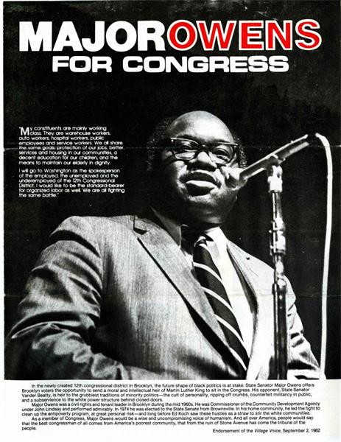
Major Robert Odell Owens (June 28, 1936 – October 21, 2013)
From his roots as a librarian at Brooklyn Public Library, to his ascent to the New York State Senate and U.S. House of Representatives, Major Owens' legacy is defined by his work as a tireless antipoverty reformer and as an advocate for education, civil rights, Americans with disabilities, workers' rights, and immigrants.
The Guide to the Major Owens Collection at the Center for Brooklyn History provides detailed documentation about his career.
He worked as a Librarian at the Brooklyn Public Library's Brownsville branch, serving as Assistant Director of Languages and Literature from 1958-1964 and as the Library's Brownsville Community Coordinator from 1964-1966.
- In 1974, Owens campaigned and was elected to the New York State Senate.
- In 1982, Congresswoman Shirley Chisholm announced her retirement, leaving a vacant seat in the city's 12th district, which included the neighborhoods of Bedford–Stuyvesant, Brownsville, and Crown Heights. Owens campaigned won 91% of the vote. In his first Congressional term he was assigned to the Government Operations Committee and Education and Labor Committee. He also joined the Congressional Black Caucus.
- He won each of the 10 subsequent elections before his retirement with at least 89% of the vote.
- Known as "The Librarian in Congress," Major Owens was also on the Education, Workforce, Government Reform, Education and Labor Subcommittee on Select Education, and Civil Rights committees during his tenure, as well as the Congressional Black Caucus (CBC) and Progressive Caucus.
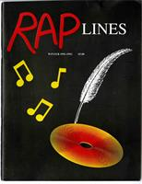
Owens wrote and performed raps, which he called "rap poems," "egghead raps," and "poetic outbursts." His lyrics appeared in the Congressional Record and were performed on the House floor, covering a variety of topics including poverty, antiwar protests, racism, and criticism of his political rivals.
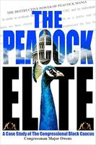
After retirement from Congress in 2006, Owens was a Senior Fellow for the DuBois-Bunche Center for Public Policy at Medgar Evers College. He was also appointed distinguished visiting scholar at the Kluge Center at the Library of Congress, a residency that allowed him to complete his case study on the Congressional Black Caucus (CBC), The Peacock Elite (2011).
More:
MEMORIAL RESOLUTION FOR MAJOR OWENS 2013-2014. ALA Memorial #2 ; 2014 ALA Midwinter Meeting . M_2_Major Owens (F).pdf
Berry, John (3 December 2013). "Major Owens: Years in politics but always a librarian". Library Journal.
"US Congressman Major Owens Named Distinguished Visiting Scholar at John W. Kluge Center". Library of Congress. 26 December 2006.
Major Owens - Wikipedia
------------------------------
Kathleen de la Peña McCook
Distinguished University Professor
School of Information
University of South Florida
------------------------------

