Sarah Edwards Obenauf
Dr. Hansen
INFO 280-10
4 May 2017

A Study in Patience and Fortitude:
A Brief History of the New York Public Library’s Early Decades
The New York Public Library was officially established on May 23, 1895. As a “burgeoning and somewhat brash metropolis” in the latter half of the 19th century, New York City already boasted libraries such as the Astor Library and the New York Society Library, where people could enjoy reading privileges by paying an annual subscription or membership fee. But as Thomas Glynn points out, for the most part these libraries were “highly specialized and consulted mostly by scholars. All of them, however, were public libraries as the term was defined when the first such collections were founded in the eighteenth century; they were accessible at least ostensibly to the general public, and they were established for the public good.” In other words, there was no “modern public library” in New York City that was free, open to the public at large, and supported with ongoing public funding. Thankfully, Samuel J. Tilden noticed this desiderata and left a significant endowment in his will that would help create the city’s first public library.
History of the Tilden Trust, Astor, and Lenox Foundations
Samuel J. Tilden (1814-1886) studied at Yale and New York University, and as a corporate lawyer, was instrumental in taking down William “Boss” Tweed and Tammany Hall. Tilden also served as Governor of the State of New York from 1875-1876, and in 1876 he unsuccessfully ran for President as a Democrat. He never married; without heirs, he bequeathed “the bulk of his estate, more than $5 million, to ‘establish and maintain a free public library and reading room in the city of New York and to promote … scientific and educational objects.’” The following year, the executors of Tilden’s estate established the Tilden Trust and elected one of their own, John Bigelow, as president. In the end, after legal fights with Tilden’s surviving family members, the Trust was able to put forth about $2.4 million to the establishment of a public library. At the time of Tilden’s death, New York City already boasted two prominent libraries: The Astor Library, a “major resource for reference and research,” and the Lenox Library, which was “intended primarily for bibliophiles and scholars” who wished to access Lenox’s personal collection of rare books, manuscripts, and Americana.
Born in Germany, John Jacob Astor (1763-1848) was a businessman, merchant, and real estate mogul. Through his will Astor established the Astor Library and provided $400,000 for the endeavor. The Astor Library was situated at Lafayette Place, not far from the Astor Place Opera House. As a general research and reference library, the Astor Library had a policy of not circulating the books in its collection; users were expected to consult and reference the books in the building.
Established by James Lenox (1800-1880), the Lenox Library came about more than twenty years later, in 1870, because Lenox—another unmarried philanthropist—was “unwilling to expose his beloved” private collection that he had acquired over the years to the “‘peril of dispersion in the auction room’ upon his death.” Since the bulk of the Lenox Library was made up of Lenox’s private collection, there was no “clearly articulated policy for developing its collection.” Lenox collected books and manuscripts which he found of personal interest, including Bibles in various languages and works by Shakespeare and Milton. Glynn summarizes that although several generous donors had helped to expand the collection, most scholars—let alone the general public—would not find it useful. The Lenox’s librarian, Wilberforce Eames, confirmed this observation when he said that the collection had books on only the “few subjects on which Mr. Lenox collected.” In addition, the Lenox Library’s uptown location on Fifth Avenue between 70th and 71st streets was far enough away from the main population of the city that the distance discouraged people from visiting. Perhaps most egregiously, the Lenox did not open itself to the general public until 1893, more than twenty years after it had been founded, and only two years before it would merge with the Astor Library and Tilden Trust to create the New York Public Library.
The Astor and Lenox libraries also shared a flawed characteristic: neither was open during the evenings or on Sundays, when visitors had free time to visit (see Figure 1).
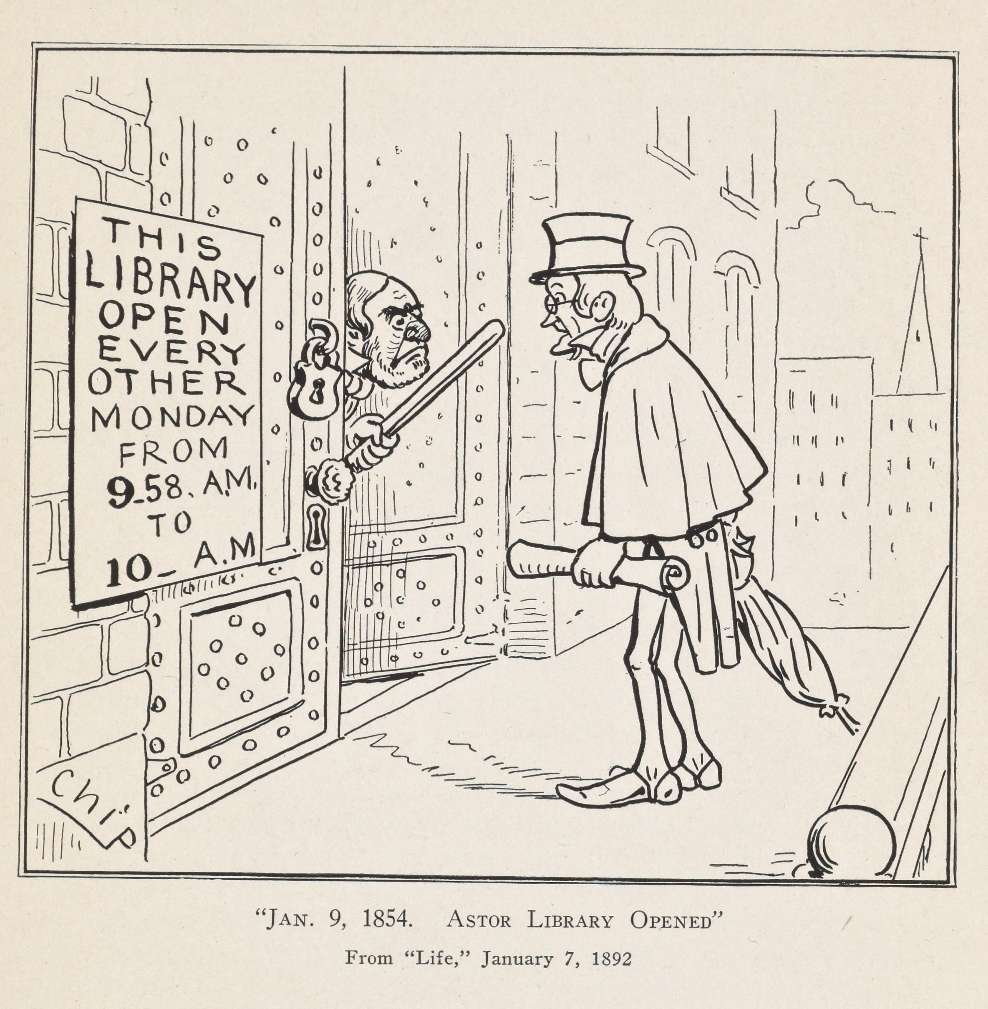
Figure 1
From The New York Public Library
https://digitalcollections.nypl.org/items/6ba99e20-85f4-0131-88e0-58d385a7b928

In addition, even though both libraries had extensive collections, neither had an endowment like the Tilden Trust. And while the Tilden Trust had a generous endowment, it did not have a collection or a building.
The first Bulletin of the New York Public Library was published in January, 1897, about a year and a half after the library’s founding. Because they provide such excellent first-hand documentation of the New York Public Library’s early history, I have relied heavily on the Bulletins and will quote them at length. Originally published on a monthly basis, the first issue outlined the histories of the Astor and Lenox libraries, the Tilden Trust, and how the New York Public Library came to be:
As a result of the exchange of views during the year 1894, between certain members of the respective Boards of Trustees, negotiations were begun early in 1895 between the three corporations […] looking to a consolidation in such form that benefits of the three institutions might be more widely disseminated among the people. The Astor and Lenox Libraries occupying somewhat the same field, were—to a certain extent—duplicating each other’s work; and their endowments, great as they were, produced revenues which were plainly insufficient to enable them to maintain reference libraries on a proper scale. It was, for example, impossible for either Library to incur the increased expenses incident to the lighting of their buildings and of keeping them open to the public except during the hours of daylight; and it was equally impossible to fill up the numerous important gaps existing in their collections, or even to keep fairly abreast of current publications. The Tilden Trust, on the other hand, while possessing an important endowment, had only the bare nucleus of a collection of books, and having no suitable building, it was apparent that any effort by its Trustees to create an independent library would simply result in leaving The Tilden Trust in a position not quite so favorable as that of either the Astor or the Lenox Libraries.

Following a “provisional understanding” in February 1895, by May 23, 1895, the three corporations formally consolidated “under the name of The New York Public Library, Astor, Lenox and Tilden Foundations.” The Introductory Statement further records that
The terms of the agreement were as simple as possible. The new corporation was to establish and maintain a free public library and reading room in the City of New York, with such branches as might be deemed advisable, and was to ‘continue and promote the several objects and purposes set forth in the several acts of incorporation of The Trustees of the Astor Library, The Trustees of the Lenox Library and The Tilden Trust.’ It was distinctly provided that the new corporation should make appropriate provision for faithfully keeping and observing all the limitations, conditions or restrictions under which any of the funds or property of the several constituent corporations were to be used or enjoyed.

Therefore, “the combined income of all three institutions presumably would be sufficient to found a public library on the scale that New Yorkers had anticipated since the announcement of the Tilden bequest more than eight years earlier” in 1886. Thus, the New York Public Library was officially formed on May 23, 1895.
The Early Years of the New York Public Library, 1895-1910
The first Board of Trustees meeting was held on May 27th, 1895. There were twenty-one men on the Board of Trustees, and six officers, including the President, John Bigelow, and the New York Public Library’s first director, Dr. John Shaw Billings. At the time of the library’s founding, there was no central building; the Astor Building, located at 40 Lafayette Place, and the Lenox Building, located at Fifth Avenue and 70th street, were open from 9am-6pm daily and were closed on Sundays and all legal holidays. The reading and exhibition rooms at both locations were open to the public free of charge, and children under the age of fifteen had to be accompanied by an adult. There were books in each building’s reading room that patrons could read while in the building; for all other books, patrons were required to fill out some simple paperwork. A retired Army surgeon and statistician, Billings served as the New York Public Library’s first director beginning in January 1896, at the recommendation of John L. Cadwalader, who was on the Board of Trustees. Cadwalader’s “appreciation of the caliber of the executive demanded by the new Library, and his knowledge of the position held by Dr. Billings in the world of scholarship, left no doubt in his mind that Dr. Billings was indeed the man they needed.” Born in Allensville, Indiana in 1838, Billings graduated from Miami University in 1857. In 1860, he received his medical degree from the Medical College of Ohio. He served as a field doctor in the US Army during the Civil War and then became head of the Library of the Surgeon General’s Office. As Dr. Debra Hansen elaborated in a recent lecture, Billings was a Renaissance man: he was an advocate of the public health movement, and developed the Index Medicus and the US System of Vital Statistics. Like many of the other male library pioneers, Billings was not formally educated in library science as we would understand it today, yet the Trustees were excited to have Billings because his “wide experience in many different fields was believed to fit him admirably not only for organizing an efficient service in the two Library buildings and furthering the usefulness of the Libraries, but also for advising as to the new building to be erected, and for planning and conducting the great development of work of the Library which is certain to follow at no distant date.” With a director such as Billings, the new library was in good hands.
Staff already in place at both the Astor and Lenox libraries kept their jobs, and any vacancies which occurred due to retirement or resignation were filled from within. At this point in time, the New York Public Library was in a unique position in that it did not occupy one central building with branches dispersed throughout the city; rather, it consisted of the Astor Building and the Lenox Building, which were approximately seven miles apart. Unfortunately, for several reasons, the Trustees viewed both locations as unsuitable as the site for the new central building. First, the Astor Library was not fireproof and lacked the space to house the extensive collections that were being planned. Second, in her will, Lenox’s sister Henrietta bequeathed a plot of land adjacent to the Lenox Building with the stipulation that it could only be built on to expand the library. “This meant,” Glynn writes, “that if the trustees built on the property, and then later moved the library to a new location, they would be legally prohibited from selling the property, unless they obtained releases from all of Henrietta Lenox’s heirs.” Perhaps most importantly, even though the Lenox Building was located near other notable cultural institutions such as the Metropolitan Museum of Art and the Museum of Natural History, it was too far removed from the city’s working-class populations. Moreover, according to Glynn,
the trustees recognized that in establishing a library of reference [emphasis added], its location would be a less critical issue, since most scholars would be willing to travel some distance in order to consult its unique collections. On the other hand, according to the board’s Site Committee, ‘a library for popular use [emphasis added], intended to reach the people, with a circulating department as an essential feature of it … would present at once as one of the main questions to be considered that of accessibility.’ Because of this, most of the city’s newspapers opposed the Lenox site. The Herald, for example, doubted whether ‘the property of the Lenox Library would be a wise selection,’ since ‘the usefulness and practical value of the consolidated library depend so greatly upon its … accessibility.’

So although the Trustees had several factors to consider, it is clear that accessibility was the most important. Consequently, they passed a “compromise resolution” at their first meeting in May, 1895, where they selected the Lenox as a conditional site.
There was, however, one area in the city that was particularly well-suited as a site for the library’s proposed central building. Located on Fifth Avenue between 40th and 42nd streets, the old Croton Reservoir (see Figure 2) in Bryant Park was closer to the more densely-populated districts further downtown, and yet easily accessible by public transportation from around the city.
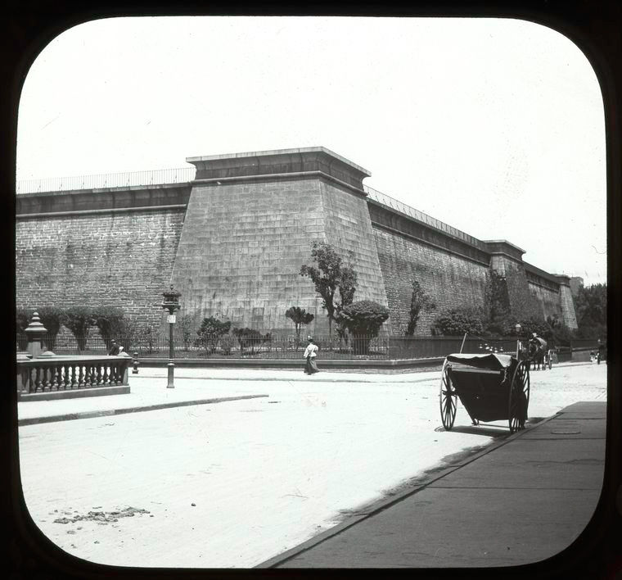
Figure 2
From The New York Public Library
https://digitalcollections.nypl.org/items/510d47da-ea3b-a3d9-e040-e00a18064a99

Because the reservoir had been decommissioned since the construction of the New Croton Aqueduct in 1893, this land also had the advantage of being public property not currently in use. After much negotiation, the City of New York signed a contract with the New York Public Library on December 8, 1897, in which the city
let to the New York Public Library the library building to be erected upon Bryant Park, to have and to hold so long as it shall continue to maintain a public library and reading room therein and so long as it shall use and occupy such building for the purpose of maintaining therein a public library and reading room and carrying on the objects and purposes of said corporation; that as soon after the completion and equipment of said building as practicable the New York Public Library shall place and arrange said building its library and collections, and shall have and enjoy the exclusive use of the whole of said building; that the said library shall be accessible at all reasonable hours and times for general use, free of expense to persons resorting thereto, one or more of the reading rooms to be open and accessible to the public upon every day of the week except Sundays, from at least nine o’clock a.m. until at least nine o’clock p.m., and on Sundays from one o’clock p.m. until nine o’clock p.m.; that they shall be established and maintained in the said library a free circulating branch open to the public during the day time on Sunday and during the evening of each other day of the week, as may be prescribed by the Board of Trustees.

Throughout the year, the Board of Trustees hosted a contest in which local architects could submit plans for the library’s central building. Some eighty-eight architects submitted plans in the first round, of which twelve were selected to continue on to the second round. Of those remaining twelve, the Board selected the architectural firm of Carrère and Hastings, which specialized in Beaux-Arts architecture, on November, 1897. It ultimately took about four years to tear down and raze the old Croton Reservoir: the Annual Director’s Reports published in the Bulletin in 1899, 1900, and 1901 speak to the bureaucracy inherent when working with multiple city and state agencies. In his 1903 report, Billings reported that the cornerstone had finally been laid on Monday, November 10th, 1902. Of the thousands who attended the ceremony, several were notable, such as the President of the Department of Parks, William R. Wilcox; the President of the New York Public Library, John Bigelow; the Mayor of New York City, Seth Low; and the Archbishop of the Diocese of New York, the Most Reverend John M. Farley. A kind of time capsule was buried into the cornerstone, and Carrère and Hastings “provided a silver and ivory trowel, suitably engraved, which was presented to the Mayor.”
Construction of the central building continued throughout the following nine years, with each subsequent Annual Director’s Report in the Bulletin detailing the progress (or, in some cases, the lack thereof). In 1903, for example, progress was incredibly slow because of a trifecta of unfortunate events: difficulty in obtaining marble, labor strikes, and an extremely cold winter. In 1904 things progressed at a faster pace. According to Billings,
Better progress has been made on the new building at 42nd Street and 5th Avenue during the year last past than in any preceding year; the severe winter allowed little work to be done between autumn and spring, but during the working period there was no serious interruption by strikes, and the amount of material delivered for the building was larger than ever before a similar period.

Progress in 1905 was even better than in 1904; in 1906, however, work on the new building was not “as satisfactory … as might be desired” due to an ironworkers’ (“housesmiths”) strike that was not settled until July. Contracts for plumbing and interior finish were advertised and awarded, while the contract for electric equipment was advertised but had not yet been awarded at the time the Bulletin was published. The construction of the main structure was finished on August 27, 1907, while work on heating and ventilation, plumbing, construction on the stacks, interior finish (masonry, marble work, metal work, cabinet work, carpentry, furring, lathing, plastering, painting, varnishing, etc.), electric equipment, and the electric power plant continued. Billings reported that the progress in 1908 was “more satisfactory this year than last” and that “labor troubles between sub-contractors and their workmen have been fewer than usual, and what strikes occurred fortunately caused no serious delays.” Work had progressed enough that the contract for furniture and equipment (including readers’ tables, desks, chairs, lighting fixtures, and more) was being written up. It is also in this bulletin that the sculptures found outside and around the building—including the famous lions, now called Patience and Fortitude—are first mentioned:
For the sculptures on the Fifth Avenue front Frederick MacMonnies has been selected to do the two statues for the niches on each side of the main entrance, the subjects suggested being ‘Wisdom’ and ‘Knowledge.’ The groups for the two pediments have been assigned to George Grey Barnard, the subjects here being ‘Science’ and ‘Art.’ The six figures over the attic are to represent ‘History,’ ‘Philosophy,’ ‘Religion,’ ‘Romance,’ ‘Poetry,’ ‘Drama,’ and are to be done by Paul W. Bartlett. Execution of the two lions on the north and south ends of the main entrance steps has been given to E[dward] C[lark] Potter.

The 1909 annual report provides a detailed description of the progress that had been made during the previous year, including the delivery of 42,296 shelves, completion of all bathroom fixtures, and the installation of both book conveyor belts by the Lamson Conveyor Company, except for the motors. In the annual report for 1910, Billings reports that most of the work had been or was currently being wrapped up. The New York Public Library’s new building was finally opened to the public in 1911.
The opening of the New York Public Library does not seem to have been treated as a major news event in a time of sensational journalism. The most interesting stories—and the only ones to include illustrations or photographs—appeared in the Sunday Magazine section of The New York Times the two weeks before the library’s opening. Other coverage was perfunctory and relegated deep to inside pages; reporters mentioned speeches given by President Taft, Governor Dix, and others as a social event which excluded the general public. Letters to the editor after the opening revealed more about the public’s mood at the time, with some complaining about the exclusivity of the opening ceremony as well as whether it is correct to tip librarians, whistling in the halls, sounds generated by chairs on the new brick floors, as well as fluted edges of drinking cups, among other cavils.
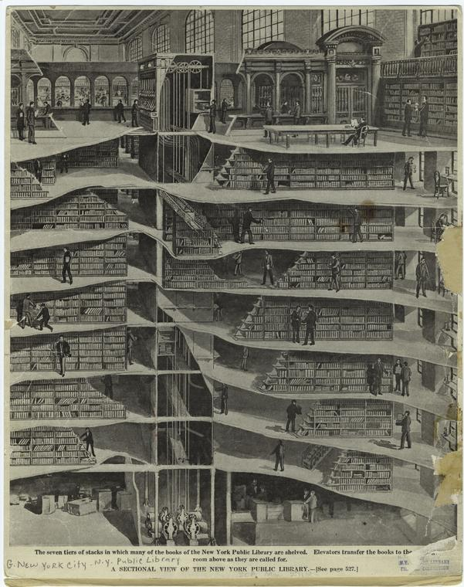
Figure 3
A Sectional View of the New York Public Library
From The New York Public Library
https://digitalcollections.nypl.org/items/510d47e0-d8bd-a3d9-e040-e00a18064a99

The original design of the central building was sketched out by Billings in 1897, which William P. Ware, professor of architecture at Columbia University, transformed into a cleaner, more readable preliminary plan (see Figure 4).
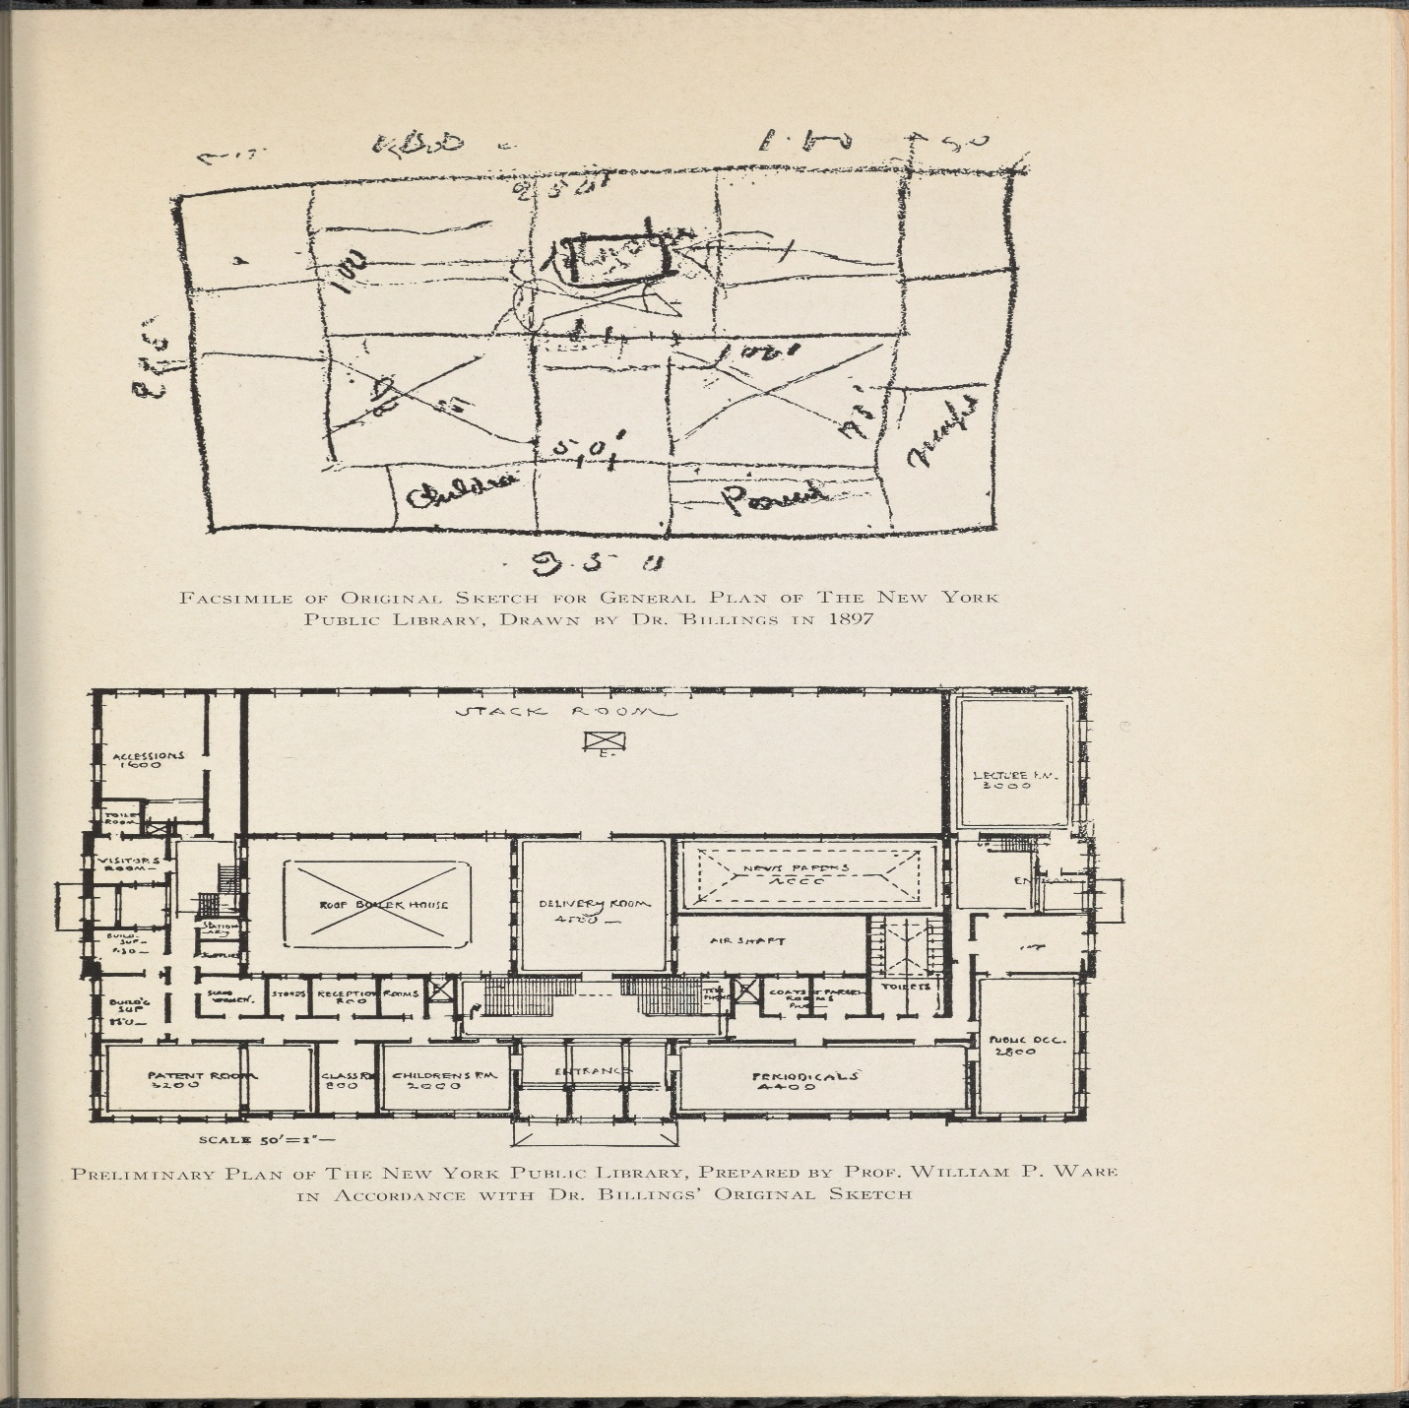
Figure 4
From The New York Public Library
https://digitalcollections.nypl.org/items/50898620-860c-0131-1592-58d385a7bbd0

The central building was Beaux-Arts in design (also known as Neoclassical), a popular style during the Gilded Age (1870s-1900) which combined Greek and Roman architecture with Renaissance motifs. Other popular examples of this type of design are Carnegie Hall and Grand Central Terminal (both in New York City), and the Palace of Fine Arts in San Francisco, CA.
Even though the construction of the central building took up a considerable amount of time, the trustees and director of the New York Public Library worked on other endeavors in the meantime. For example, in 1900 the Comptroller of the City asked the library to investigate and report on the “condition, resources and methods of the fourteen library corporations which at that time were receiving aid from the City based upon their free circulation of books.” This investigation led to the first consolidation of libraries into the New York Public Library, beginning with the New York Free Circulating Library in February, 1901. Incorporated in 1880, the New York Free Circulating Library operated thirteen branch libraries and managed 1.6 million volumes annually. But, perhaps most importantly, in March, 1901, Andrew Carnegie wrote to Billings, offering to “provide funds for the construction of sixty-five branch library buildings in the five boroughs, at an average cost of $80,000, or $5,200,000 in all, if the City would furnish the sites and provide for the maintenance of the libraries when built.” In addition, Carnegie gave $15,000 to the New York Public Library on May 9, 1911, so that a library school could be established in the central building “primarily to provide the library with trained assistants and incidentally to fit for library positions elsewhere suitable candidates who do not care to reside in New York.” The library accepted Carnegie’s offer and donation and appointed Mary W. Plummer, former librarian of the Pratt Institute and director of the Pratt Institute library school as the principal. In this way, Carnegie became instrumental in consolidating the various branch libraries in New York City. When the central building opened, library cards from any of the branches were also valid at the new library.
The New York Public Library, 1911-1920
On May 23, 1911, sixteen years after the first Board of Trustees meeting of the newly-formed New York Public Library, the library was officially dedicated and opened to the public. In the Report of the Trustees, First Vice-President John L. Cadwalader and Secretary Charles Howland Russell wrote that
The year 1911 has been memorable in the history of this corporation. As a result of twenty years of planning and construction, the library resources of the City have been brought under one management, and the collections of books, prints and pictures formerly housed in the Astor Library and the Lenox Library are now permanently combined in the magnificent building erected by the City of New York.

He beamed that this “great library project”

has provided the people of the City of New York with a commanding central reference library, with a circulating library system of unique extent and completeness, including a well equipped branch library in every part of the three boroughs of Manhattan, The Bronx and Richmond, with a total collection of books in both departments aggregating about 2,000,000 volumes, and with unlimited possibilities of expansion and usefulness.

He further boasted, perhaps rightfully, that if,

as Cicero said, the education of the people is the highest function of a state, we are justified in congratulating ourselves heartily upon the establishment in the very centre of our municipal life of this great university of learning, with its incalculable education influence upon the present generation as well as upon future generations.

By combining the holdings of the Astor and Lenox libraries with the collection curated by the New York Public Library, upon the new building’s opening there were “839,867 books, 302,274 pamphlets, 73,109 prints, 7,000 maps and a considerable number of paintings,” with “1,000,000 books and pamphlets in the seven floors of steel stacks, 20,000 books on the shelves of the main reading room, where there are seats for about 800 readers, and 100,000 books in fifteen special reading rooms devoted respectively to Americana, art and architecture, maps, music, prints, genealogy, Slavonic literature, Jewish literature, Oriental literature, science, economics, public documents, technology, patents and a library for the blind.” Cadwalader and Howland Russell continue: “Each of these rooms is in charge of an expert in the respective subjects, who is prepared to aid readers and students. These special collections of books are carefully selected and are designed to meet the ordinary needs of the student of the respective departments, but each collection may be supplemented by volumes brought from the main stacks.” Special note was made of the work put in to attract children in both the Reference and Circulation departments; in the years leading up to 1911, children visited the branch libraries so often that by 1911 their numbers exceeded one million. In addition, “the opening of the commodious and attractive children’s room in the central building has given a fresh impetus to the effort [of attracting children to the library], and has increased the general interest in the subject.” Cadwalader and Howland Russell remarked that “it is a pleasant and stimulating sight to see this new children’s room in use, and one cannot but feel that here is an education influence of distinct power for good.”
In 1911 the New York Public Library employed 927 people throughout the central building and branches. Salaries totaled $572,107.56; 37% ($209,485.49) was paid to employees of the Reference Department. The remaining 63% ($362,622.07) was paid to employees of the Circulation Department, which included the forty library branches. Delivery wagons were also necessary in order to get books to and from the central building and the branches; in 1911 more than $6,000 was spent on their purchase and maintenance.
The central building’s first full day of operation was May 24, 1911; between that day and December 31, 1911, 173,180 readers visited the general and special reading rooms and requested 614,200 books. Compared to the same time period for the year prior, the number of visitors increased almost 150%. (only 70,000 people visited both the Astor and Lenox libraries). Cadwalader and Howland Russell continue:
Including those who have registered as readers, 1,582,870 people have visited the new building. For the entire year [of 1911] the number of readers was 246,950, and they consulted 911,891 volumes. In the Circulation Department the number of volumes owned has increased to 877,672, the total number of readers who have registered at the forty branch libraries during the year has been 316,908, and the number of volumes circulated for home use has been 7,914,882, an increase of 407,906 [or 5.4%] over the year 1910.

Billings also discusses the number of visitors and volumes consulted in his annual report, which immediately follows that of the trustees. The total number of readers/visitors for the entire year was 246,950, with 43,970 visiting the Astor and Lenox buildings and 202,980 visiting the new central building. Readers had available to them a total of 2,019,813 pieces (839,867 volumes, 302,274 pamphlets, and 877,672 items in the circulation department available for home use). Billings continues:
The print room contains 73,109 prints, the map room 7,000 maps. There were catalogued 59,053 volumes, 42,566 pamphlets, and 72 maps; the public catalogues contain 1,716,191 cards, the official catalogue 819,533, and catalogues in special rooms 1,086,906, making a net total of 3,631,630 cards. 1,852 periodicals were indexed number by number, for which 18,647 cards or printed slips were written. Periodicals currently received amount to 6,927 if counted by titles, or 167,259 if counted by individual pieces. Readers of current periodicals numbered 64,612, and the periodicals consulted by them 305,175. The printing office set 57,969 card titles, from which were run off 501,124 cards; in addition 2,922,224 stationery forms and 147,650 single numbers of publications were printed.

In the circulation department the number of branches remains at 40. The record of volumes in the department has increased from 809,350 to 877,672. The circulation for home use has increased from 7,506,975 to 7,914,882.

The total expenditures for the calendar years 1911 were $1,114,179.95 of which $419,712.70 was spent for the reference department and $694,467.25 for the circulation department.

These truly staggering numbers—along with accession reports—demonstrate the width and breadth of the subjects one could read about and discover at the New York Public Library. In addition to the director’s report, the heads of each division in the Reference Department, building maintenance, and the Circulation Department prepared reports, as well as staff who were in charge of other activities, such as scheduling meetings and conferences, working with school children, the traveling library, and the library school. Billings concludes his annual report for 1911 by stating
I wish to thank the members of the staff for the willing assistance rendered so freely and loyally. To this spirit of earnest support must be credited much of the success attained during the year. During the trying period of preparation for removal, the two months of moving, and the discomforts of adjustment to new conditions the staff worked early and late, without complaint, and the result is one for which the Board may well thank them individually and collectively.

Accession of items, attendance by visitors, and other pertinent statistics (books checked out or referenced, for example) continued to grow over the next few years. Billings died on March 11, 1913, less than two years after the central building opened, and his co-director, Edwin Anderson succeeded him.
The year 1916 saw a dip in visitor and circulation numbers because of an epidemic of polio which spread throughout the city, and “children under sixteen were forbidden the use of the Branch Libraries or Travelling Library Stations from July 7th to September 25th.” However, “the rate of increase in the use of the Circulation Department, both by adults and by children, before this regulation went into effect, and the increase in the adult use throughout the year, show that if the epidemic had not occurred the circulation for the year would have been greater than that in 1915 by about 800,000 volumes.”
The director’s annual reports discussed the need for more funds in order to adequately run the New York Public Library as early as 1915. This need stemmed from the fact that the reference and circulation departments were two distinct entities which had different sources of funding. While the costs associated with the circulation department in the forty branches were borne by the City of New York, “the entire expense of the reference department” as well as the circulation department at the central building was the responsibility of the “Public Library from its own funds, without any yearly contribution by the City toward maintenance as is usual with the museums and other public institutions of the city.” In 1916, even with the polio epidemic, patrons’ needs increased (which included significant increases in the number of visitors to the library on Sundays and holidays) while there was “no relative increase in financial resources” which caused the library difficulty in “maintaining its present position—to say nothing of progressing—because it [was] hampered for lack of funds.”
The United States entered World War I on April 6, 1917, which had an immediate effect on the New York Public Library. Twenty-seven staff members resigned in order to join the military or serve their country in some other way. In addition, 204 others in the reference and circulation departments resigned in order to take better-paying jobs elsewhere that could afford to pay higher wages, such as “commercial establishments in New York, and Government bureaus and departments in Washington.” The 1919 bulletin stated plainly and succinctly that the library had seen a decrease in visitors and overall use thanks to the war (many of those who would normally use the library’s services were away serving the country), and this phenomenon was common among “all institutions performing similar functions” as the New York Public Library. The central building even played a role in the war effort, hosting campaigns for the Red Cross, Savings Stamps, United War Work and others; collecting books for soldiers and sailors; and the north and south ends of the terrace served as a kind of canteen for officers and enlisted men. “Because of its favorable location,” writes Lewis Cass Ledyard, President of the Board of Trustees, “this space has been of great value in these war activities, although its occupation for these purposes has, no doubt, interfered with the normal use of the Library by its patrons.” The circulation department also experienced a decrease in usage due to a shortage of coal which caused twenty-one branches to be closed from anywhere for a few hours to almost six weeks, as well as the flu epidemic, during which no books could be checked out from the branches by order of the Commissioner of Health.
World War I ended on November 11, 1918. In his annual report for that year, Anderson closes with some ruminations on the event:
In many respects the most obvious series of events, as the year comes to an end and its months are reviewed, was the use made of the terraces in front of the Library. Not a ‘drive’ for any war activity was started, but a booth or a set of standards or a painting was added to the numerous forms of extra-library equipment with which the building was already provided. Military and naval bands of all degrees of excellence and loudness, firing squads of sailors or marines or soldiers giving salutes with great variety in volume of sound and in rapidity, troops of performing elephants, singers from the opera, stage celebrities, tanks, airplanes, wooden ships, canvas tents, wooden huts, ambulances, and a bewildering succession of other evidences of the war made it difficult to realize that behind these enormous crowds stood a library trying to conduct its usual work. Parades became so common as scarcely to cause a ripple of excitement, but it is safe to say that no one who saw the crowds packed in front of the building on the 7th and 11th of November [1918] will ever forget the sight or the event.

He adds that in addition to those

whose services to the country necessitated their absence from the Library, it is fitting that a word of appreciation should be uttered for members of the staff who, remaining at their accustomed duties, nevertheless did patriotic work of one kind or another in their own time. Especially is the Library indebted to members of the staff who resisted financially tempting offers, and loyally stayed at their posts here.

After the war, the year 1919 witnessed an “increased demand by the public upon the facilities of the Library” in both the reference and circulation departments. Nevertheless, the library still struggled to keep up with its “hopes, obligations and responsibilities,” which Anderson viewed as a direct result of “the new conditions resulting from the war.” Decreases in the availability of funds as well as inflation “actually reduced purchases to from one-third to one-half of what they were five years ago [in 1914].” Anderson continues:
In consequence it has not been possible to develop our collections systematically, to strengthen the weak places and maintain the strong. The funds available have made it possible to keep up moderately well with current publications, but the Library cannot provide for the present and future demands of scholars if it stops there. The Library has a responsibility to the far-sighted men who bought its books in the past, and a responsibility to the investigator in the next generation, which cannot be met by the mere selection of the books of to-day. Instead of $30,000 or $50,000 a year, the Library should have at least $100,000 if it is to live up to its opportunities and meet its proper obligations.

Visitors to and usage of the library continued to increase throughout the following year, and in 1920 a donation of $1,000,000 was made to the library’s endowment fund by Mrs. Stephen V. Harkness. In addition, some trustee members contributed a total of $115,000 to aid in reducing the library’s deficit; the report takes care to note that “all of these contributions were voluntary and spontaneous, none of them having been solicited.” According to the director, however, the library was still dealing with negative effects due to the war, most notably the inability to hire and retain “young men and boys for pages and messengers,” when the potential employees could make more money working elsewhere. This problem resulted in “delayed delivery of books to readers, and increased frequency of errors,” but was remedied by the end of the year, though the director does not say how it happened.
Conclusion
In studying the volumes of the Bulletin of the New York Public Library for the research for this paper, I have been struck by the difference in tone between the New York Public Library of the 1890s and the New York Public Library of 1920. The first bulletin, from 1899, lauded the growing collection and number of employees; it had an overall exuberance for what the future would hold. On the other hand, in 1920, the library was running at a deficit and was still reeling from the war, along with other cultural institutions and the country as a whole. Concerns that we know all too well today—such as the continuous need for more funding for libraries, and staff being overworked and underpaid—were also a reality then. It was (and still is) with patience and fortitude that the New York Public Library has managed to remain one of the pillars of our cultural heritage.

References
“50,000 Visitors See New Public Library.” The New York Times, May 25, 1911. Accessed May
4, 2017. https://nyti.ms/2pMvZbp.

“City’s $29,000,000 Library Is Opened.” The New York Times, May 25, 1911. Accessed May 4,
2017. https://nyti.ms/2pMtB4G.

Glynn, Tom. Reading Publics: New York City’s Public Libraries, 1754-1911. New York:
Fordham University Press, 2015.

Hansen, Debra. “Session 12 Lecture Part 1.” Webcast lecture. 30:18.
http://amazon.sjsu.edu/html-lmain/flash2011/session12part1.html.

Lydenberg, Harry Miller. History of the New York Public Library Astor, Lenox and Tilden
Foundations. Boston: Greg Press, 1972. First published 1923 by the New York Public
Library.

The New York Public Library. Bulletin of the New York Public Library vol. 1 (1897).

---. Bulletin of the New York Public Library vol. 2 (1898).

---. Bulletin of the New York Public Library vol. 3 (1899).

---. Bulletin of the New York Public Library vol. 4 (1900).

---. Bulletin of the New York Public Library vol. 5 (1901).

---. Bulletin of the New York Public Library vol. 7 (1903).

---. Bulletin of the New York Public Library vol. 8 (1904).

---. Bulletin of the New York Public Library vol. 9 (1905).

---. Bulletin of the New York Public Library vol. 10 (1906).

---. Bulletin of the New York Public Library vol. 11 (1907).

---. Bulletin of the New York Public Library vol. 12 (1908).

---. Bulletin of the New York Public Library vol. 13 (1909).

---. Bulletin of the New York Public Library vol. 14 (1910).

---. Bulletin of the New York Public Library vol. 15 (1911).

---. Bulletin of the New York Public Library vol. 16 (1912).

---. Bulletin of the New York Public Library vol. 17 (1913).

---. Bulletin of the New York Public Library vol. 022 (1917).

---. Bulletin of the New York Public Library vol. 22 (1918).

---. Bulletin of the New York Public Library vol. 23 (1919).

---. Bulletin of the New York Public Library vol. 24 (1920).

---. Bulletin of the New York Public Library vol. 25 (1921).

---. “History of The New York Public Library.” Accessed May 3,
2017. https://www.nypl.org/help/about-nypl/history.

Appendix A
Page 85 of the Bulletin of the New York Public Library vol. 5 (1901)
From The Hathi Trust
https://babel.hathitrust.org/cgi/pt?id=uc1.b3309877;view=1up;seq=99

New York Public Library, “History of The New York Public Library,” accessed May 3, 2017, https://www.nypl.org/help/about-nypl/history; Tom Glynn, Reading Publics: New York City’s Public Libraries, 1754-1911 (New York: Fordham University Press, 2015), 1.
Glynn, Reading Publics, 1–2.
Ibid., 15.
Harry Miller Lydenberg, History of the New York Public Library Astor, Lenox and Tilden Foundations (1923; repr., Boston: Greg Press, 1972), 129.
Glynn, Reading Publics, 224.
Ibid., 224.
Ibid., 225; New York Public Library, “History.”
New York Public Library, “History.”
Glynn, Reading Publics, 161.
Ibid., 156.
Ibid., 158.
Ibid., 158.
Ibid., 158.
Ibid., 162. When the new NYPL finally opened in 1911, The New York Times approvingly wrote that the new library would be “open every day in the year, including … Sundays and holidays.” They note that librarians and their assistants deserve days off like other people, “but it is not necessary that they should all have the same days for their own purposes.”
The New York Public Library, Bulletin of the New York Public Library vol. 1 (New York: New York Public Library, 1897), 10.
Ibid., 11.
Ibid., 11.
Glynn, Reading Publics, 229.
New York Public Library, Bulletin vol. 1, 2.
Ibid., 2.
Harry Miller Lydenberg, History of the New York Public Library Astor, Lenox and Tilden Foundations (1923; repr., Boston: Greg Press, 1972), 351.
Debra Hansen, “Session 12 Lecture Part 1,” Webcast lecture, 30:18, http://amazon.sjsu.edu/html-lmain/flash2011/session12part1.html.
New York Public Library, Bulletin vol. 1, 12.
Lydenberg, History, 351.
Glynn, Reading Publics, 232.
Ibid., 232.
Ibid., 232–3.
Ibid., 232.
Ibid., 234.
New York Public Library, Bulletin of the New York Public Library vol. 2 (New York: New York Public Library, 1898), 370.
Ibid., 369.
New York Public Library, Bulletin of the New York Public Library vol. 3 (New York: New York Public Library, 1899); New York Public Library, Bulletin of the New York Public Library vol. 4 (New York: New York Public Library, 1900); New York Public Library, Bulletin of the New York Public Library vol. 5 (New York: New York Public Library, 1901). I was unable to locate a Bulletin for 1902.
New York Public Library, Bulletin of the New York Public Library vol. 7 (New York: New York Public Library, 1903), 362.
Ibid., 362–3.
Ibid., 363. The documents that were buried in the cornerstone were listed in the 1902 Bulletin, which I was unable to locate. The New York Times did not record the occasion.
New York Public Library, Bulletin of the New York Public Library, vol. 8 (New York: New York Public Library, 1904), 476.
New York Public Library, Bulletin of the New York Public Library, vol. 9 (New York: New York Public Library, 1905), 400.
New York Public Library, Bulletin of the New York Public Library, vol. 10 (New York: New York Public Library, 1906), 492; New York Public Library, Bulletin of the New York Public Library, vol. 11 (New York: New York Public Library, 1907), 464.
New York Public Library, Bulletin of the New York Public Library, vol. 11 (New York: New York Public Library, 1907), 464.
New York Public Library, Bulletin of the New York Public Library, vol. 12 (New York: New York Public Library, 1908), 80–2.
New York Public Library, Bulletin of the New York Public Library, vol. 13 (New York: New York Public Library, 1909), 80.
Ibid., 81. For more information on the NYPL Lions, please see https://www.nypl.org/help/about-nypl/library-lions.
New York Public Library, Bulletin of the New York Public Library, vol. 14 (New York: New York Public Library, 1910), 69–71.
New York Public Library, Bulletin of the New York Public Library, vol. 15 (New York: New York Public Library, 1911), 56–8.
On May 14, 1911, the Sunday Magazine of the New York Times ran a feature with a sectional view of the central building. The following week, on May 21, the Magazine ran a feature on the revolutionary new mechanical and electrical systems in the state-of-the-art library ahead of its grand opening that week. NYT digital subscribers can view these images at https://nyti.ms/2pM01wf and https://nyti.ms/2pbpuuY.
“City’s $29,000,000 Library Is Opened,” The New York Times, May 24, 1911, accessed May 4, 2017, https://nyti.ms/2pMtB4G.
New York Public Library, Bulletin of the New York Public Library, vol. 16 (New York: New York Public Library, 1912), 81.
Ibid., 82. The other libraries that consolidated with the New York Public Library were: The St. Agnes Free Library, chartered in 1894; the Washington Heights Free Library, chartered in 1868; the New York Free Circulating Library for the Blind, chartered in 1895; the Aguilar Free Library Society, chartered in 1886; the Harlem Library, chartered in 1871; the Tottenville Library Association, chartered in 1899; the Cathedral Free Circulating Library, chartered in 1896; the Library of the University Settlement Society; and the Webster Free Library.
Ibid., 82. At the time the 1912 bulletin was published, thirty-seven of the proposed sixty-five branches had been built. See Appendix A for a copy of Carnegie’s letter.
Ibid., 89.
“50,000 Visitors See New Public Library,” The New York Times, May 25, 1911, accessed May 4, 2017, https://nyti.ms/2pMvZbp.
New York Public Library, Bulletin of the New York Public Library, vol. 16 (New York: New York Public Library, 1912), 79.
Ibid., 79
Ibid., 79.
Ibid., 80.
Ibid., 80–1.
Ibid., 82.
Ibid., 83.
Ibid., 83.
Ibid., 87.
Ibid., 88.
Ibid., 83.
Ibid., 83.
Ibid., 83.
Ibid., 90.
Ibid., 177.
The New York Public Library, Bulletin of the New York Public Library vol. 22 (New York: New York Public Library, 1917), 163.
Ibid., 163.
The New York Public Library, Bulletin of the New York Public Library vol. 17 (New York: New York Public Library, 1913), 93.
The New York Public Library, Bulletin of the New York Public Library vol. 022 (New York: New York Public Library, 1917), 164.
Ibid., 164.
The New York Public Library, Bulletin of the New York Public Library vol. 23 (New York: New York Public Library, 1919), 175.
Ibid., 175–6.
Ibid., 186.
Ibid., 197–8.
Ibid., 197–8.
New York Public Library, Bulletin of the New York Public Library vol. 24 (New York: New York Public Library, 1920), 107.
Ibid., 117.
Ibid., 117.
Ibid., 117.
New York Public Library, Bulletin of the New York Public Library vol 25 (New York: New York Public Library, 1921), 192.
Ibid., 192.
Ibid., 201.
Ibid., 201.

