A brief history of the Medical Library of the University of Missouri

When the University of Missouri Medical School was established in 1872, the small collection that was the medical library was housed therein. In 1903, McAlester Hall was completed and the medical library moved to occupy one room in the new building. Over time, the library expanded to occupy three rooms in McAlister Hall.
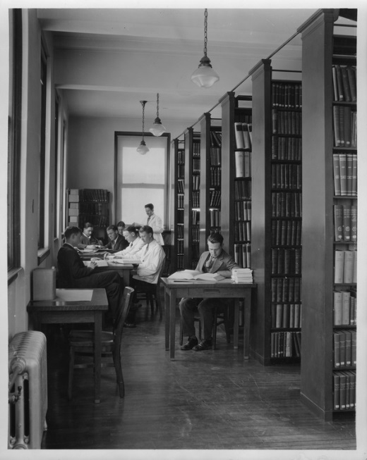
Medical Library in McAlester Hall, 1925
C:1/83/16
University Archives
A new academic medical center opened in 1956, with the medical library located in the link joining the teaching hospital and the medical sciences building. The library had two floors and occupied 12,608 square feet. At the end of 1956, the library had 26,000 volumes, 663 journals, 139 seats, had no special collections, but was strong in anatomy and physiology.
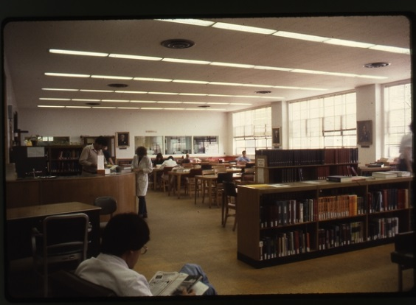
HSL Reading Room, May 1982
C:20/8/6
University Archives
In the early 1960s, a new health sciences library was discussed, but funding for a new library was given top priority when the Liaison Committee on Medical Education found the existing library to be inadequate to support the medical school. In 1982 plans for the new facility began in earnest.
In 1985, the new J. Otto Lottes Health Sciences Library building was completed. It had a collection of over 200,000 volumes and a full-time staff of twenty-one. The library, which boasted a microcomputer learning laboratory and an online search room, had three floors, with over 50,000 usable square feet of space. The learning laboratory had eighteen computers and there were an additional ten computers located in an open library area.
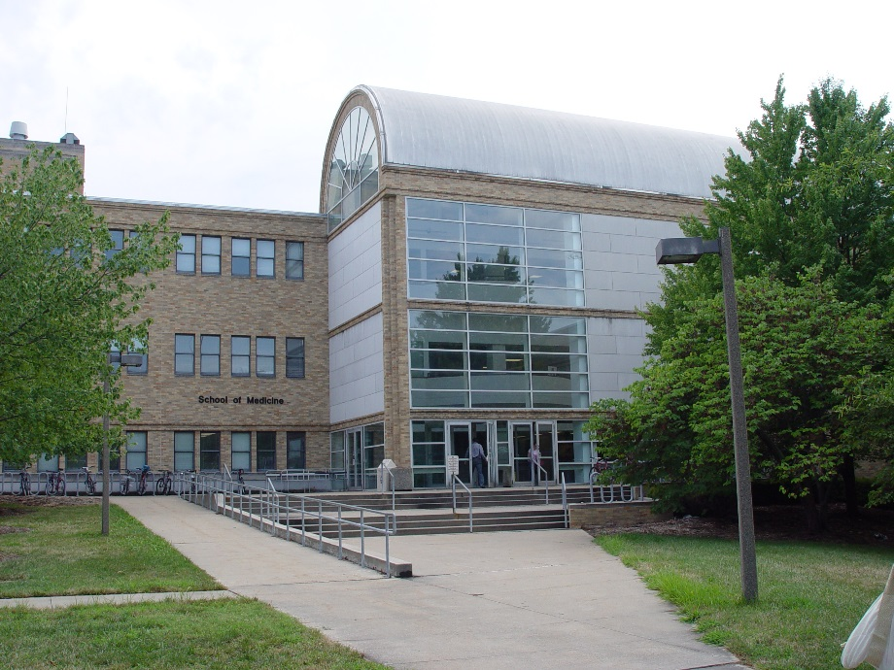
Outside of the Health Sciences Library, 2013
In 2015 the Health Sciences Library celebrated its 25th anniversary. In 2016, the library reported the following: 272,772 physical volumes, 3,612 journal subscriptions, 58 public work stations, 414 seats and a gate count of 135,144. In 2017, the library continues to adapt to meet the changing needs of its users and hopes to renovate the existing space in the future.

